VERTEBROPLASTY
In the past, surgeons used standard open surgery to fix compression fractures from osteoporosis. Open surgery requires larger incisions to give the surgeon more room to operate. The results of open surgery for this condition have generally been poor, mainly because it is difficult to do surgery on bones that are weak and soft from osteoporosis. In addition, some aging adults with fractures may not be physically able to tolerate such surgery.

What is Vertebroplasty?
Vertebroplasty is a nonsurgical therapy performed under fluoroscopy (image guidance machine) to strengthen damaged vertebra using cement. It can be performed by radiologists or trained spinal surgeons. Typically the cement is injected to strengthen and stablise certain collapsed vertebral body (bones of the spine) fractures due to osteoporosis, tumor or trauma. It is not suitable for all fractures which assists with reducing pain on mobilisation and preventing further collapse.
Vertebroplasty gives surgeons a way to treat the broken bone without the problems associated with open surgery. Unlike open surgery, vertebroplasty is a minimally invasive procedure. It requires small openings in the skin only and small instruments. This lessens the chance of bleeding, infection, and injury to muscles and tissues. Surgeons fix the bone in place by squeezing special cement into the broken bone. The cement strengthens and stiffens the vertebra, which reduces pain considerably and helps the patient return to normal activities.
This procedure doesn't restore the original height of the broken vertebra, however. Nor does it prevent the kyphosis (hunchback) deformity that sometimes results from compression fractures

Vertebroplasty has the advantage of achieving both rapid pain relief and restoring bone strength, with many studies showing that up to 90% of patients become completely painfree two to three days post procedure. Over several weeks, patients can expect a marked decrease in their doses of pain medications, and can expect to increase mobility and activity levels. Vertebroplasty cannot correct curvature of the spine caused by osteoporosis, but may help to prevent further deterioration. The procedure treats only the acutely fractured vertebra and does not prevent future compression fractures. This procedure is best done within 6 weeks of the fracture.

Suitable candidate:
- Acute (< 1 month) fracture; results mixed in subacute fractures (<6 weeks). Should not be done for chronic fractures unless as part of elective fusion or deformity correction.
- No major kyphosis (focal angulation)
- No obvious segment instability or malaligned vertebrae
- No major retropulsion or significant posterior cortical wall disruption (i.e. more than a ‘crack’ through the posterior wall of the vertebra may allow cement leakage)
- No neurological / spinal cord dysfunction as a result of the fracture that would need decompression or instrumented stabilisation

Why do I need this procedure?
Vertebroplasty is usually performed within 3 weeks of a thoracolumbar fracture (lower thoracic, upper lumbar) when you continue to experience severe positional pain when upright despite simpler treatments, such as bed rest, back bracing, or if pain medication no longer works, or have begun to cause other problems, such as stomach ulcers and/or drowsiness due to medications.
The procedure is often performed on patients who cannot or do not want open spinal surgery, are unfit for major surgery or with bones too weak for surgical spinal repair.
What should I expect and what happens?
The patient lies on his or her stomach. To begin, the surgeon cleans the skin on the back with an antiseptic. An anaesthetist will give you twilight sedation and make you as comfortable as possible with the surgeon injection local anaesthetic. After using the local anaesthetic to numb the targeted area’s skin, a needle will be directed into the fractured vertebrae under guidance, and once the tip of the needle is in the correct position, then the cement is injected. The longest part of the procedure is setting up the equipment and safe positioning the needle. The actual injection of cement takes only 10 minutes but the cement can take about 15 mins to fully cure.
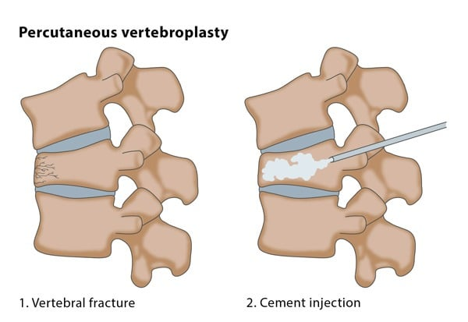
Once the needle is in place, special bone cement, called polymethylmethacrylate (PMMA), is injected through the needle into the fractured vertebra.

A chemical reaction in the cement causes it to harden in about 15 minutes. This fixes the bone so it can heal. Bandages are placed over the small openings where the needles were inserted.

You may be a little sore after the procedure, but your symptoms should gradually disappear. If you are an inpatient or being admitted, you will go from recovery to your hospital room afterward where the staff will monitor you. Each patient’s length of stay will vary.
Risks and benefits:
You will be asked to sign a consent form. It is important that you understand the procedure and its benefits and risks.
The procedure benefits are avoiding the complications of prolonged recumbency and medications and relieving pain. Vertebroplasty is safe and effective in most cases, the procedure should be performed only if a patient has back pain that significantly impairs mobility and quality of life.
Significant complications from vertebroplasty are rare. Vertebroplasty short term complication rates have been reported at less than 10%. Potential complications include bleeding, infection, and worsening of pain.
There is a very rare risk of injury to nerves or the spinal cord. Since the cement is injected as a liquid, it can leak out of the vertebral body into surrounding tissues and veins, which may lead to the nerve roots or the spinal cord being irritated or compressed. In very rare cases, the cement may leak into the lungs causing pulmonary embolism or can form micro-emboli in the veins which can travel to the heart.
After your Vertebroplasty If being done as a day procedure, you will need to stay for monitoring for at least one to two hours after the procedure to make sure there are no complications. You MUST have someone else drive you home at the end of this observation time and be able to rest until the following morning. It is recommended that someone else be available during this time should you require any assistance.

Dr Zotti recommends following the procedure that you confer with your bone endocrine specialist or general practitioner regarding prevention and further treatment of any underlying osteoporosis or osteopenia.

